Jennifer Stegina

9 September 2019

CIS 250

**Unit 3 Graded Exercise 1**

The following questions come from the “Check your understanding” examples of each section of Chapter 7 in your textbook.

After you are finished, please submit a Microsoft Word file that contains screenshots of the SQL queries and the output. Additionally, put a comment line in each query containing your name. Your document should be named **U3_GradedExercise1_Lastname.docx**.

(7-2) Question 1:

Modify the *select* statement in this section to display the *hire_date* column in the format: January 10, 2012.

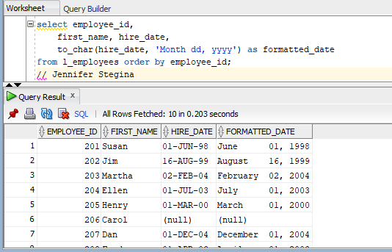

(7-3) Question 2:

Add a new row to a copy of the employees table, *sec0703_employees*. Set the hire date to show that the person was hired at 10:00 AM.

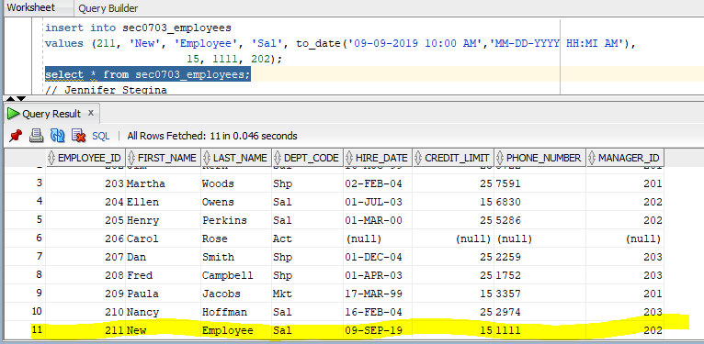

(7-6) Question 3:

Create a new sequence named *seq0706_my_stuff*. Set the beginning value to 100.

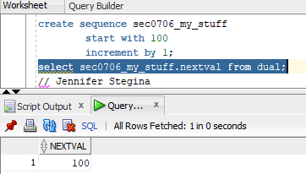

(7-7) Question 4:

Determine the current value of the sequence *seq_sec0707*. Then use its next three values to add new rows to the *sec0707_sequence* table. This table has only one column. It holds the value of the sequence number.

I had to run nextval because currval throws the “you have not set the value for this session” error.

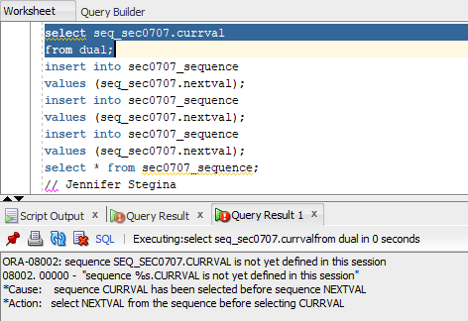

So, I entered nextval and then currval.

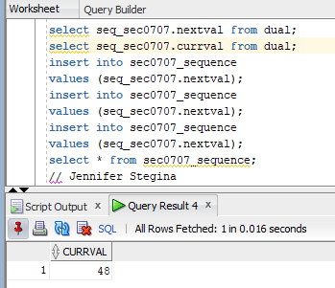

I did enter and run everything that you said via email (I did the same from the book before emailing you), but it is still telling me that the table does not exist. Pic included to show.

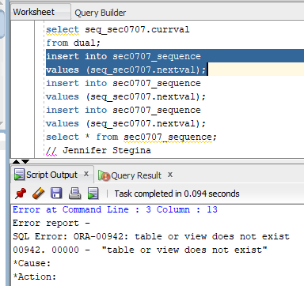

(7-9) Question 5:

Build an index on a copy of the departments table, *sec0709_departments*. Index the *department_name* field.

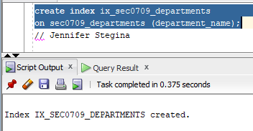

(7-12) Question 6:

Find information about the datatypes of all the columns of the *l_foods* table.

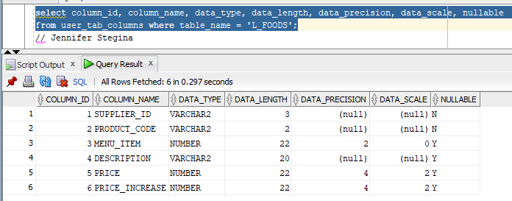

(7-14) Question 7:

Find out what indexes there are on the *l_departments* table.

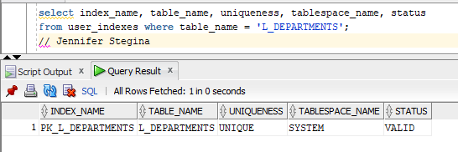

(7-16) Question 8:

Find all the tables in the Oracle Data Dictionary about views.

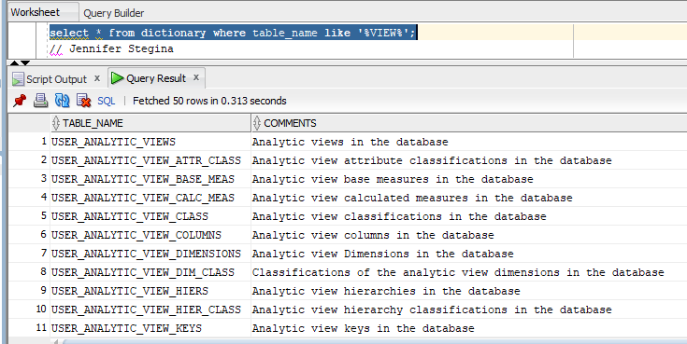

(7-17) Question 9:

Find the meanings of all the columns of the *user_tables* table.

